# **Introduction**

## **Background**

Nowadays, messaging applications are very popular among communication within people. So we decide to create an application, users need to login and open chatroom to chat with other users. Voice messaging also become a new popular way to communicate with others using application but the issue may face by them is voice message can’t hear clearly. It might be happened in scenario like either the mic got problem or the background noises affect the quality of the audio message. So this project can provide user a function to choose whether they can use text message or voice message, but if receiver didn’t hear voice message clearly, they can choose to transform voice message to text. Moreover, this function isn’t common among the top rated social media applications such as Messenger, WhatsApp and others. But WeChat application provides this function for users, and it works so amazing.

## **Objective**

1. To reduce time used in typing.
2. To increase the understanding between users
3. To reduce time when user talk to each other’s
4. To provide user friendly interface
5. To provide a better communication experience

# **Modeling the requirements**

## **Use case diagram**

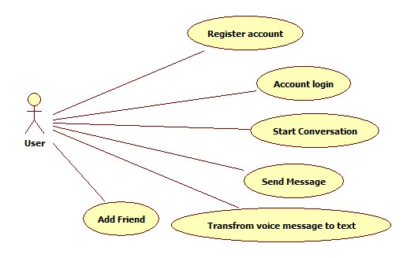

Figure 1.1 Use case diagram

## **Use Cases**

|  |  |
| --- | --- |
| Use Case Name | Send Message |
| Actor | App user |
| Description | Users want to send a message to friends. They can send two type of message either voice or text. |

|  |  |
| --- | --- |
| Use Case Name | Transform voice message to text |
| Actor | App user |
| Description | Users want to transform a voice message which is not clear enough to a text message. |

|  |  |
| --- | --- |
| Use Case Name | Add friend |
| Actor | App user |
| Description | Users want to add a new friend. After added successful, system will display in friend list. |

## Expanded Use Cases

|  |  |  |
| --- | --- | --- |
| **Use Case 4** | Send message | |
| **Goal in Context** | To allow user to send messages | |
| **Primary Actor**  **Secondary Actor** | App user | |
| **Trigger** | User want to send messages to friends | |
| **Typical Course of Events** | | |
| **Actor Action** | | **System Response** |
| 1. This use case begins when a user want to send messages to friends | |  |
| 2. User choose either voice message or text message. | | 3. The system will display the sent message in chat room. |
| 4. User close the chat room. | |  |
| **Alternative Course of Events** | | |
| Line 2a: If user choose voice message, user required hold the speak button and talk. | | |
| Line 2b: If user want to send more message repeat line 2. | | |

|  |  |  |
| --- | --- | --- |
| **Use Case 5** | Transform voice message to text | |
| **Goal in Context** | To allow user transform voice message to text | |
| **Primary Actor**  **Secondary Actor** | App user | |
| **Trigger** | User want to transform voice message to text | |
| **Typical Course of Events** | | |
| **Actor Action** | | **System Response** |
| 1. This use case begins when a user want to transform voice message to text | |  |
| 2. User choose and hold the selected message that he or she want. | | 3. The system will pop out a option to choose the “Transformation from voice to text” |
| 4. User cancel the option. | |  |
| **Alternative Course of Events** | | |
| Line 2: If user want to transform another voice message repeat line 2. | | |

|  |  |  |
| --- | --- | --- |
| **Use Case 6** | Add Friend | |
| **Goal in Context** | To allow user to add friend | |
| **Primary Actor**  **Secondary Actor** | App user | |
| **Trigger** | User want to add new friend | |
| **Typical Course of Events** | | |
| **Actor Action** | | **System Response** |
| 1. This use case begins when a user want to add new friend | |  |
| 2. User enter the account ID of friend to search | | 3. The system display the info of that account like name. |
| 4. User click “add friend” | | 5. The system will add this new friend to the user’s friend list. |
| 6 User cancel this option. | |  |
| **Alternative Course of Events** | | |
| Line 2: If user want to add more friends repeat line 2. | | |

## Analysis Class Diagram

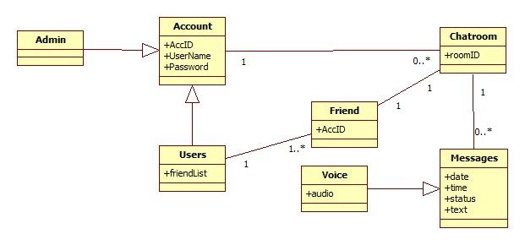

# Updated Gantt Chart

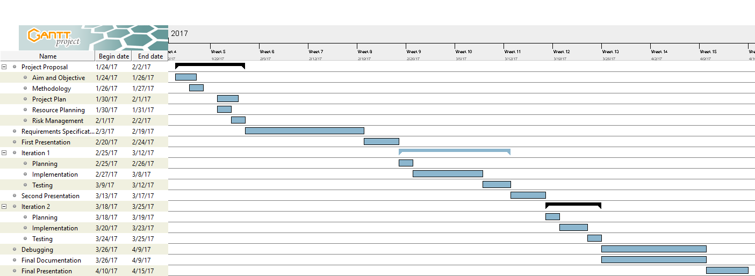

# References

1. *WhatsApp Requirements Specification*. *Dan Frost*. Retrieved 19 February 2017, from http://frost.ics.uci.edu/inf43/SampleSRS5.pdf